HARDWARE COMPONENTS

INTRODUCTION

Hardware components are the physical parts of a computer system that work together to perform various functions. These components can be broadly categorized into internal and external hardware. Internal components, such as the **Central Processing Unit (CPU), motherboard, Random Access Memory (RAM), storage devices, and power supply**, are essential for processing and storing data. External components, like **monitors, keyboards, mice, printers, and external storage devices**, allow users to interact with the system.

Each hardware component plays a vital role in ensuring the smooth operation of a computer. The CPU acts as the brain of the system, while RAM provides temporary storage for active tasks, and storage devices (HDDs, SSDs) retain data long-term. The motherboard connects all components, allowing communication between them. Understanding these hardware components is crucial for troubleshooting, upgrading, or building a computer system.

**Common Hardware Components**

1. **Central Processing Unit (CPU)** – The brain of the computer that processes instructions and executes tasks.
2. **Motherboard** – The main circuit board that connects all hardware components and allows communication between them.
3. **Random Access Memory (RAM)** – Temporary memory that stores active data and programs for quick access.
4. **Storage Devices** – Includes **Hard Disk Drives (HDDs)** and **Solid State Drives (SSDs)** for long-term data storage.
5. **Power Supply Unit (PSU)** – Converts electrical power from an outlet into usable power for computer components.
6. **Graphics Processing Unit (GPU)** – Handles rendering of images, videos, and graphics, essential for gaming and design applications.
7. **Input Devices** – Includes peripherals like **keyboards, mice, scanners, and webcams** for user interaction.
8. **Output Devices** – Devices like **monitors, printers, and speakers** that display or project processed data.
9. **Cooling System** – Includes fans, heat sinks, and liquid cooling solutions to regulate temperature and prevent overheating.
10. **Network Interface Card (NIC)** – Enables wired or wireless internet connectivity.

Each component plays a crucial role in the overall functioning of a computer system.

**CENTRAL PROCESSING UNIT (CPU)**

The **Central Processing Unit (CPU)** is the brain of a computer, responsible for executing instructions and processing data. It performs calculations, manages tasks, and controls the operation of other hardware components.

**Key Components of a CPU:**

1. **Control Unit (CU)** – Directs the flow of data and manages instructions.
2. **Arithmetic Logic Unit (ALU)** – Performs mathematical calculations and logical operations.
3. **Registers** – Small storage locations inside the CPU for quick data access.
4. **Cache Memory** – High-speed memory that stores frequently used instructions for faster processing.

**CPU Performance Factors:**

* **Clock Speed (GHz):** Determines how many instructions the CPU can process per second.
* **Cores:** Multi-core CPUs (e.g., dual-core, quad-core) allow multiple tasks to be processed simultaneously.
* **Threads:** Virtual processing units that enhance multitasking.
* **Cache Size:** Larger cache improves performance by reducing data retrieval time.

Popular CPU manufacturers include **Intel** and **AMD**, offering processors for various needs, from basic computing to high-end gaming and professional workloads.

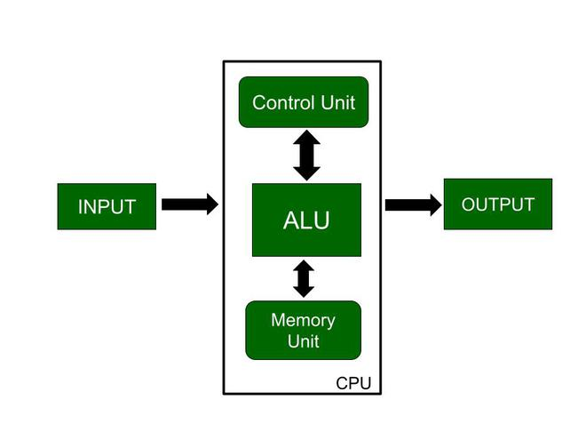

**MEMORY (RAM)**

Random Access Memory (RAM) is a type of volatile memory that temporarily stores data and instructions that the CPU actively uses. It allows for fast data access, improving system performance and multitasking capabilities.

Key Features of RAM:

* Volatile: Data is lost when power is turned off.
* Fast Access: Much quicker than storage devices like HDDs and SSDs.
* Temporary Storage: Holds active programs and files for smooth operation.

Types of RAM:

1. Dynamic RAM (DRAM): Commonly used in computers, requires constant refreshing.
2. Static RAM (SRAM): Faster and more expensive, used in cache memory.

Factors Affecting RAM Performance:

* Capacity (GB): More RAM allows better multitasking.
* Speed (MHz/MT/s): Faster RAM improves data transfer rates.
* DDR Versions: DDR3, DDR4, DDR5—newer versions offer higher speed and efficiency.

More RAM results in a smoother and more responsive system, especially for gaming, video editing, and other memory-intensive tasks.

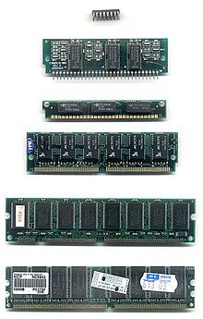

**Hard Disk Drive (HDD)**

A **Hard Disk Drive (HDD)** is a **non-volatile** storage device used to store operating systems, software, files, and data permanently. Unlike RAM, data in an HDD is retained even when the computer is powered off.

**Key Features of HDD:**

* **Magnetic Storage:** Uses spinning disks (platters) and a read/write head.
* **High Capacity:** Typically ranges from **500GB to 10TB** or more.
* **Slower than SSDs:** Due to mechanical parts, HDDs have slower read/write speeds.
* **Cost-Effective:** Cheaper per GB compared to SSDs.

**Types of HDDs:**

1. **Internal HDD:** Installed inside computers and laptops.
2. **External HDD:** Portable and connects via USB for backup/storage.

HDDs are widely used for large-scale storage, though **Solid State Drives (SSDs)** are becoming more popular due to their speed and durability.

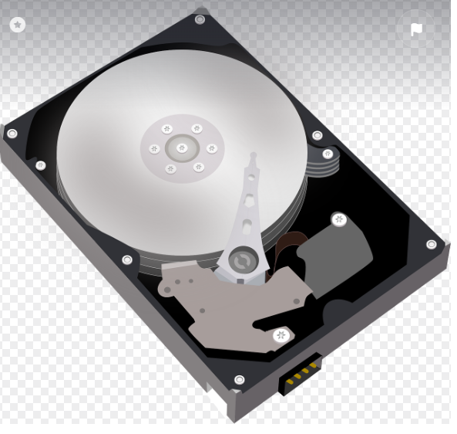

**Motherboard**

A computer motherboard is a large, flat circuit board that serves as the central hub for all other computer components, typically identifiable by its complex network of integrated circuits, connectors for various peripherals like RAM, CPU, and expansion cards, and often featuring heat sinks and cooling fans attached to key components like the chipset; visually, it looks like a printed circuit board with numerous soldered components and clearly marked slots for attaching other hardware.

Key components easily identifiable on a motherboard:

* **CPU Socket:**

A large, square or rectangular area with pins designed to hold the central processing unit (CPU) securely.

* **RAM Slots:**

Multiple slots where small, rectangular RAM modules (memory sticks) are inserted.

* **Chipset:**

A large integrated circuit often covered by a heat sink, responsible for managing communication between the CPU and other components.

* **PCIe Slots:**

Expansion slots for adding graphics cards, network cards, or other peripherals.

* **Power Connectors:**

Multiple power connectors to supply electricity to the motherboard from the power supply unit.

* **I/O Panel:**

A section with various ports like USB, audio jacks, network connections, and display outputs.

* **Heat Sinks and Fans:**

Metal fins designed to dissipate heat from the CPU and chipset, often with a fan attached.

How to identify a motherboard:

* **Size and Form Factor:**

Motherboards come in different sizes like ATX, Micro ATX, Mini ITX, which can be identified by their shape and screw mounting points.

* **Manufacturer Logo and Model Number:**

Most motherboards have the manufacturer's logo and model number printed directly on the board, usually near the CPU socket.

* **Color Coding:**

Different colored traces on the board can help identify specific components and their connections.

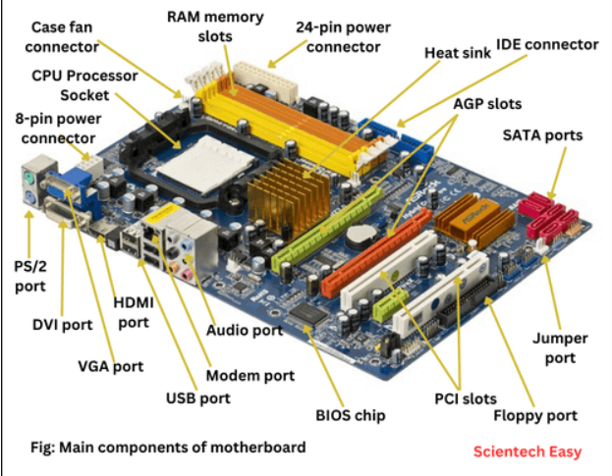

**Daughter card**

A daughter card, also known as a daughterboard, piggyback board, or riser card, is a small circuit board that connects to a computer's motherboard. It's designed to extend the functionality of the motherboard.

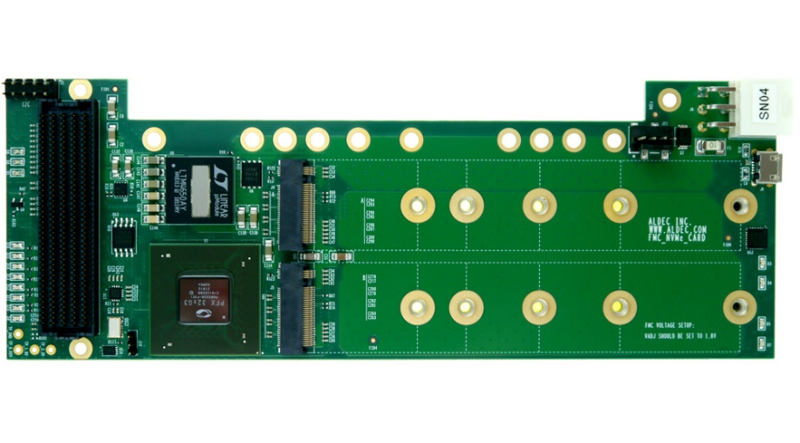

**Bus Slot**

An expansion slot is a bus slot or expansion port found on the motherboard of a computer. It performs as a socket on the motherboard. Basically, it holds expansion cards featured in a computer so that it can use those features for better operation—say, a video card for better graphics and sound, Ethernet for an increased internet speed, and memory for an increased storage capacity. Any slot on the motherboard that can hold an expansion card is an expansion slot.

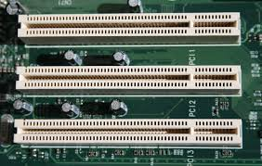

**SMPS**

SMPS stands for Switched Mode Power Supply, which is a power supply unit (PSU) that converts electrical power for a computer. It's also known as a switcher.

A switched-mode power supply (SMPS), also called switching-mode power supply, switch-mode power supply, switched power supply, or simply switcher, is an electronic power supply that incorporates a switching regulator to convert electrical power efficiently.

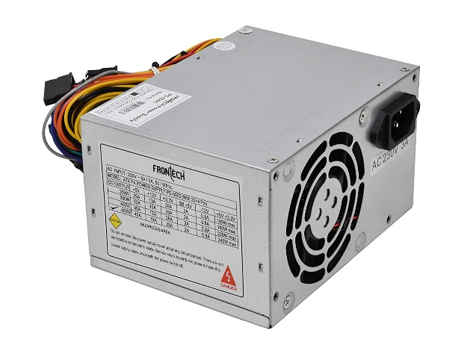

**Internal storage devices**

Internal storage devices are permanently installed inside a computer and include magnetic storage devices, solid state drives (SSDs), optical drives, and flash memory devices.

* **Magnetic storage devices**

Typically hard drives that are magnetic in nature

* **Solid state drives (SSDs)**

Store data in an integrated circuit and can be used as internal or external drives

* **Optical drives**

Can be internal or external and are installed directly into the computer's electronics

* **Flash memory devices**

Usually built-in and house the operating system and files needed for the device to operate

**Interfacing ports**

Interfacing ports are communication channels that allow a microprocessor to communicate with external devices. They can be used to read data from input devices like keyboards and mice, and to send data to output devices like CRT displays.

* **Parallel port**: Also known as a printer port, this was an industry standard for many years in the late 1990s.

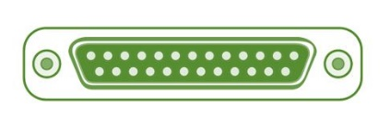

* **Ethernet port**: Connects a network cable to a computer, allowing it to connect to a network and the internet.

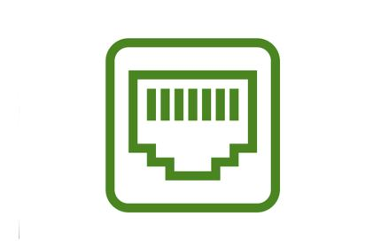

* **PS2 port**: An interface for keyboards and mice to communicate with the host.

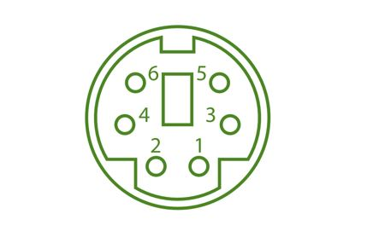

* **Serial port**: A port that can be used for data communication.

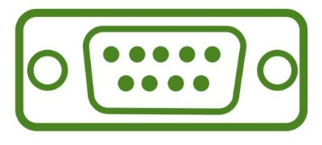

* **USB port**: An interface that supports plug and play, and can be used to connect a Universal Serial Bus (USB) device to a computer.

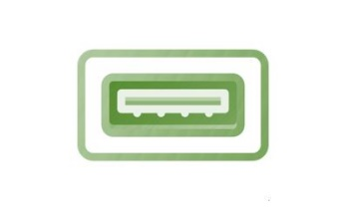

* **FireWire port**: A type of serial port that can be used to connect audio and video devices to computers.

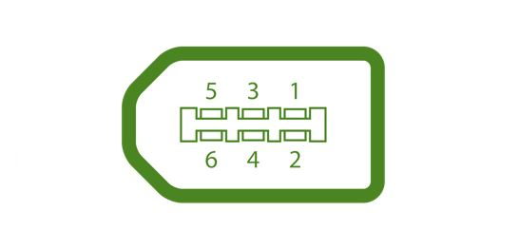

**HDMI port**: A common interface for onboard connections

**Conclusion**

Hardware components are the backbone of any computer system, working together to ensure efficient performance. From the **CPU** that processes data to **RAM** that provides temporary storage, and **HDDs/SSDs** that store data permanently, each component has a specific role. Input and output devices enable user interaction, while the **motherboard** connects all parts. Understanding these components is essential for troubleshooting, upgrading, and optimizing system performance. As technology advances, hardware continues to evolve, leading to faster, more powerful, and energy-efficient computing solutions.

Submitted by: **NANDANA SUBHASH**

Roll no:**18Bottom of Form**

Top of Form